**TRIGGERING ACTIONS ON INCREASE CPU UTILIZATION BY CLOUDWATCH**

**Flow chart: -**

Creating EC2 instance and copying instance ID

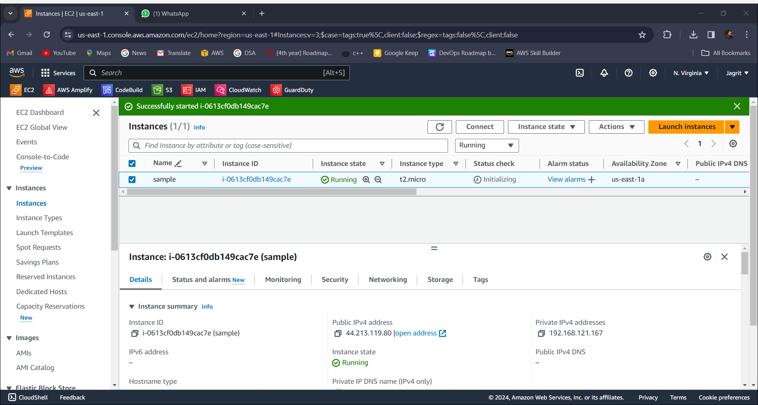

Setting up an SNS service and creating a subscription

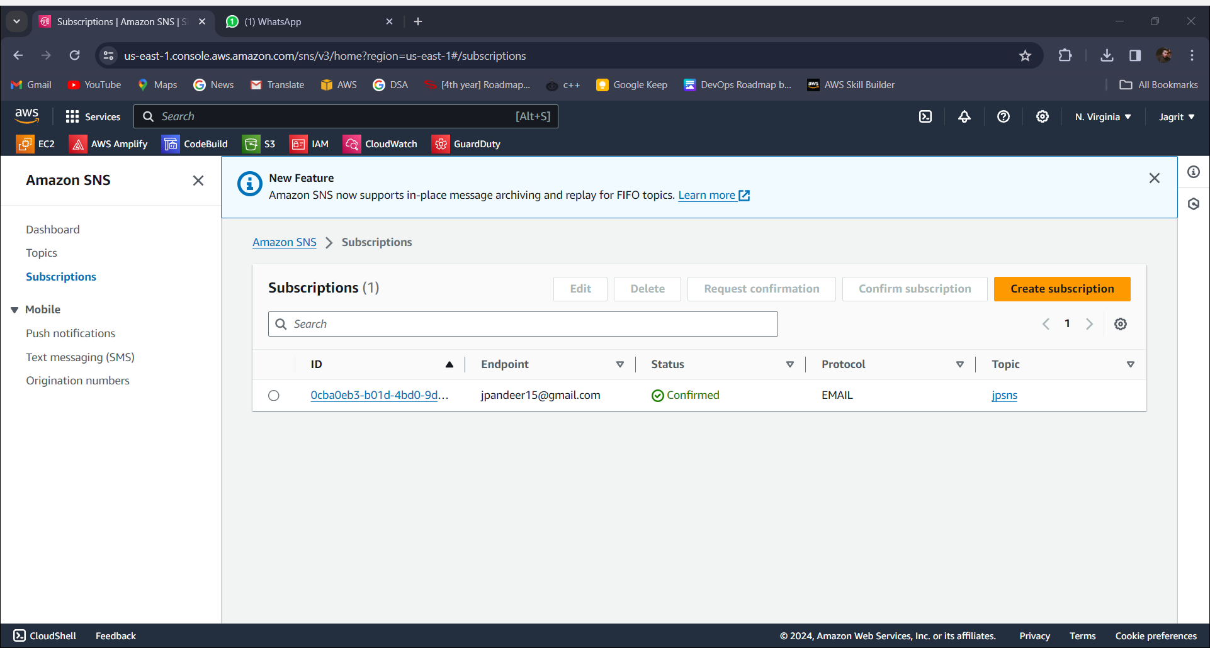

Setting up CloudWatch

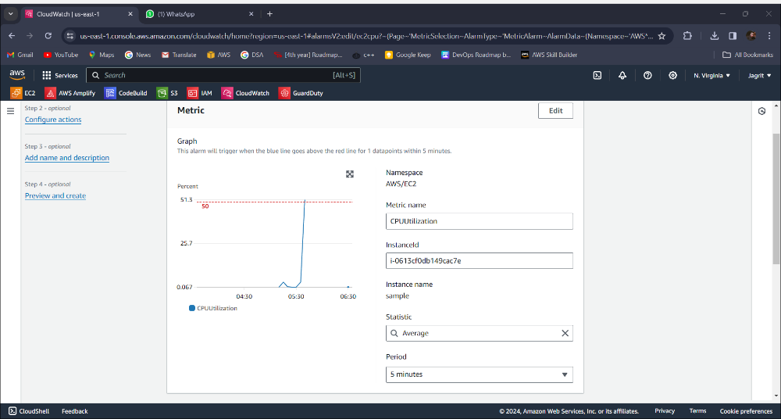

Giving instance ID and selecting metric as CPU utilization

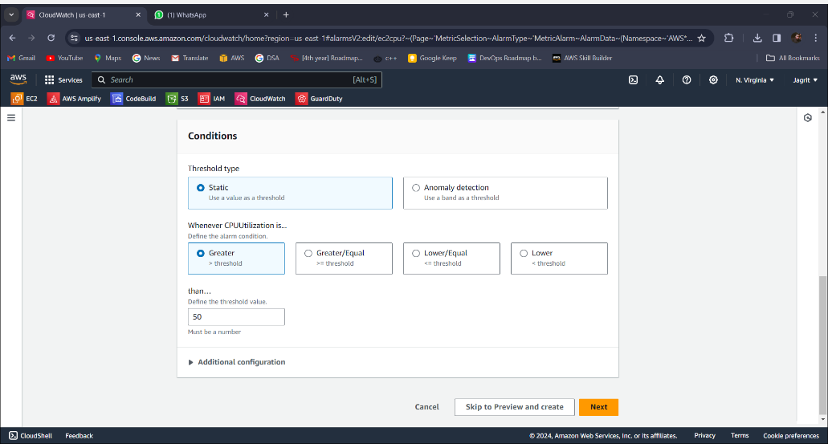

Providing threshold value

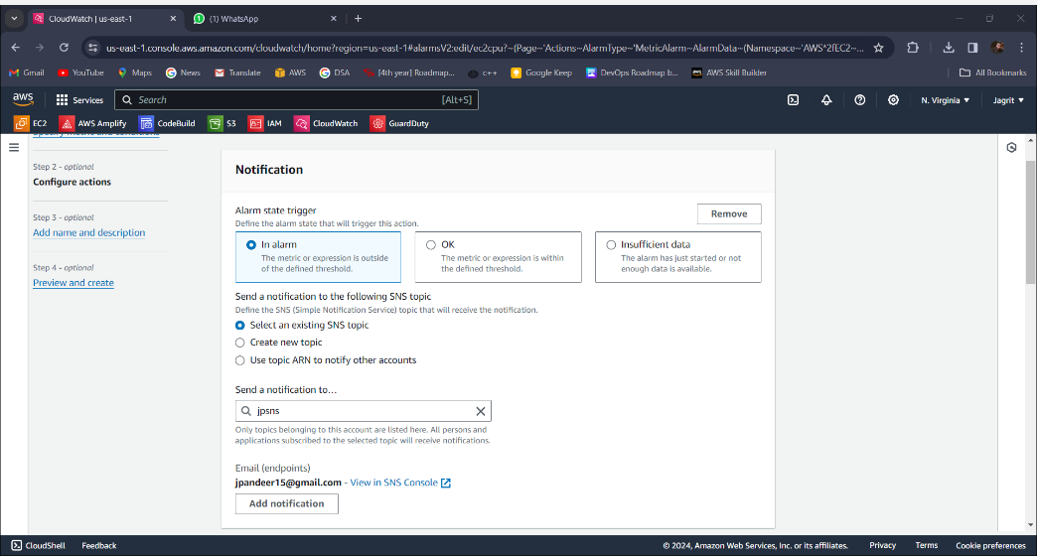

Providing SNS trigger

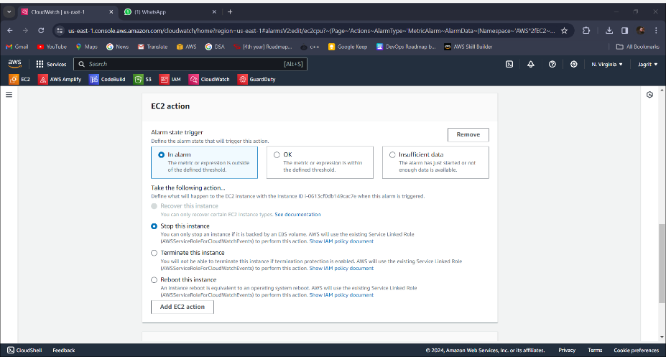

Setting EC2 stop action when crossing the threshold

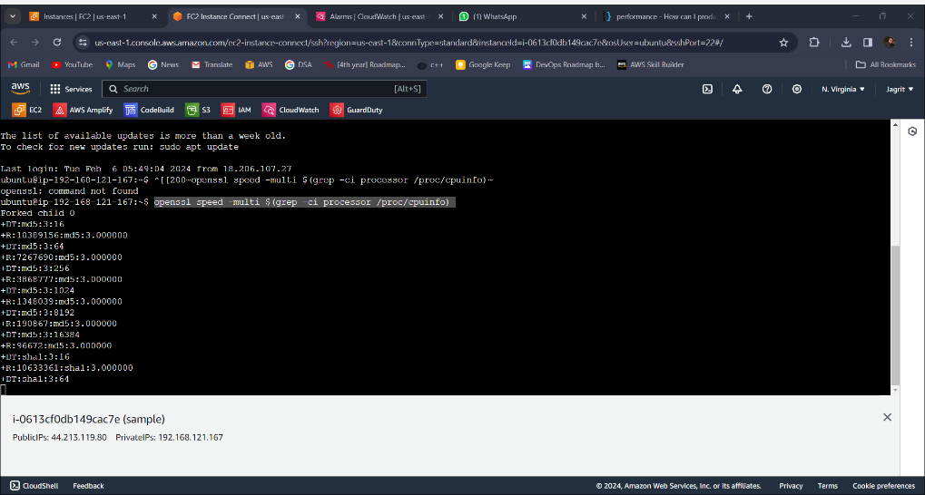

With openssl speed -multi $(grep -ci processor /proc/cpuinfo) command we increase the CPU utilization for testing

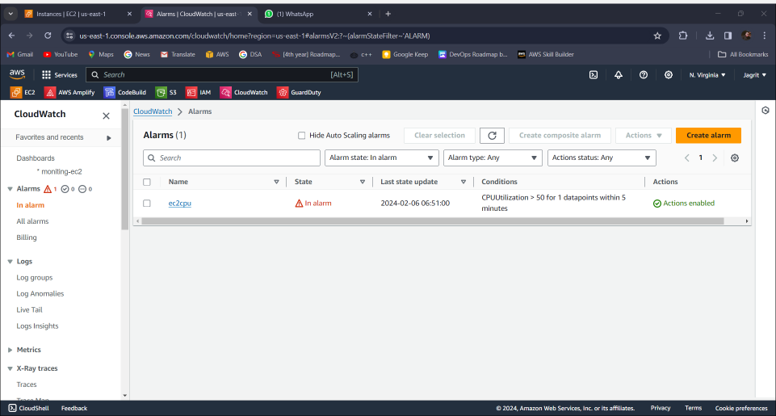

When the CPU threshold increases by 50%, an alarm is triggered

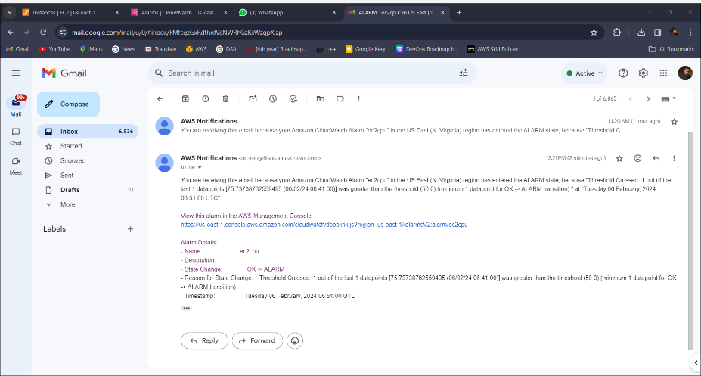

Mail received

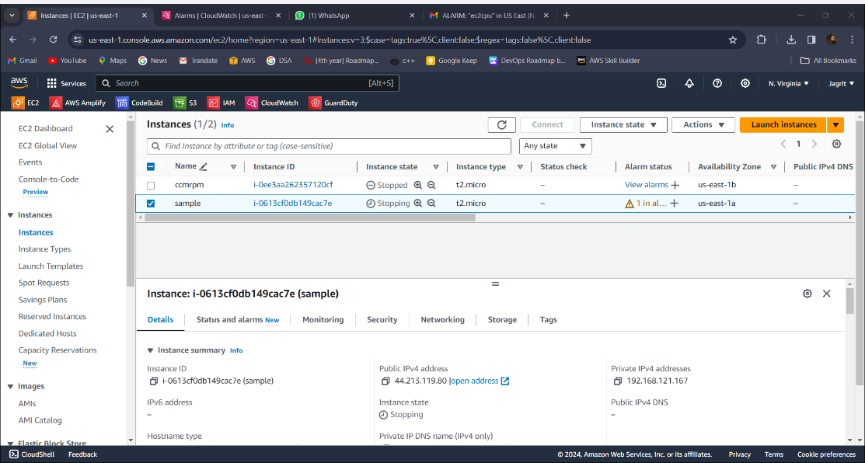

And EC2 instance state changed to stopping